Deployment.yaml | Creates pods
- StatefulSet.yaml | Creates pods with constant name(created on the same name upon recreation) and in linear order
Service.yaml | Service – network abstraction layer.  Forwards traffic to respective pod&port*.
Types of Service:
- LoadBalancer – LB forwards the incoming request from public to pods | not used when ingress is used.
- ClusterIP – Forwards the requests from one pod to another pod in the same cluster. | *mostly used
- ExternalName - Forwards the requests from pods to external services
pvc.yaml  StorageClass | Creates volume  requests volume from the Cloud service provider as requested by PVC specs and PVC claims it.
Ingress.yaml(K8s)  - Route.yaml(OCP) | Creates networking route from public to inside the cluster
Configmap | Creates a config file of all the envt variables needed/used in deployment manifest  envFrom:  - configMapRef:  name: app-config
Secrets | To store secrets in a secured format
Network policies | Restricting communication between pods  Without network policies:  - Frontend pod can directly talk to database pod if frontend application is calling database  With network policies:  - Frontend pod is restricted to talk to database directly.

Setting up a cluster

Setting up networking
Install CNI
- enables pod to pod communication
Install Ingress Controller: Nginx/AWS/AGIC
- enables internet to pod communication
Command:
helm install ingress-nginx ingress-nginx/ingress-nginx \
--namespace ingress-nginx \
--create-namespace

Upon installing the controller, it creates a service(load balancer/gateway) to route traffic from internet to this controller
NGINX Ingress Controller = the controller pod creates a LB and handles traffic. | AGIC = the controller pod configures Azure Application Gateway; the gateway handles the traffic.
Installing nginx controller will also install a service: Load balancer(creates LB in the cloud), that load balancer route the traffic from internet to Nginx pod, then nginx pod to app’s pod.  (based on the ingress resource) | Installing AGIC controller, creates AppGW and configures the AppGW with the paths specified in ingress.yaml.  that AG will route the traffic from internet to app’s respective pod.  (based on the ingress resource)
Internet  |  Load Balancer  |  NGINX Pod  |(ingress.yaml)  Service  |  Pod | Internet  |  Application Gateway  |(ingress.yaml)  Service  |  Pod
OCP has it’s own network controller: OCP Router,
With the provided router,
- we need to create an AG and attach it to the ocp router.
- ocp router will forward the traffic to the pod
(based on the routes)

Internet
|
AppGW
|
OCP Router(provided by OCP by default)
|(routes.yaml)
Service
|
Pod

Access, Authentication, Authorization
Entry point: Kube API Server
- kubectl commands will reach kube API server on executing any commands
Authentication:
- Human users authenticated by
  - OpenIDConnect, Oauth
  - Client certificates
- Machines authenticated by
  - Service accounts
Authorization: authz by RBAC
- binds users/groups/service accounts to the role.
Request sent to node will be authorized by RBAC and then be executed.
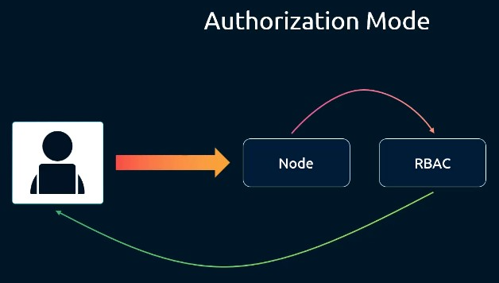
Before auth & authz, Communication bw components are secured through TLS certificates.
Eg: communication between kubelet <---> API Server are secured through TLS Channel.
Namespace Vs Cluster Permissions:
- Developers get namespace scoped permissions
- Administrators get Cluster scoped permissions

